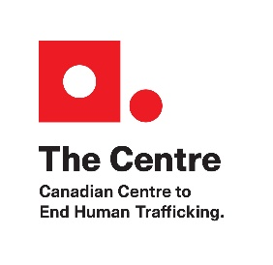

The Canadian Human Trafficking Hotline
The Canadian Centre to End Human Trafficking (The Centre) has been advocating to the Federal Department of Public Safety to support the implementation of a National Human Trafficking Hotline in Canada. We are pleased to share that The Centre’s proposal has been successfully funded, and the Canadian Human Trafficking Hotline is live and taking calls as of May 29, 2019. This dedicated, expert, and survivor-informed hotline will accept calls involving all forms of human trafficking, including both sex and labour trafficking, and provide assistance to and on behalf of minors, adults, citizens, permanent residents, and foreign nationals. In short, the hotline will serve anyone, anytime, anywhere.

The hotline will use a victim-centered approach to connect human trafficking victims and survivors with local emergency, transition, and/or long-term supports and services across the country, as well as municipal, provincial and/or federal law enforcement, as appropriate. All hotline staff will receive extensive, trauma-informed training on human trafficking to ensure a timely, specialized, and effective response, as well as Indigenous-specific cultural competency training to support Indigenous callers. Overall, the hotline will act as a central mechanism for referrals, offering 24/7, multilingual, confidential access to services across Canada.

The hotline will not act as an investigative body, nor will it act as a direct service provider. It will instead provide a crucial alternative point of access for victims and survivors, as well as anonymous callers with third party tips. Independent of government and law enforcement, the hotline will increase callers’ options for support, thereby broadening the safety net available to them.

Building Collaborative Relationships
The hotline is focused on working with front-line service providers and law enforcement in communities across Canada to develop localized Referral and Reporting Protocols. By engaging all relevant actors, a robust, immediate response to our callers is ensured. In doing so, the hotline also aims to facilitate collaboration amongst organizations across Canada at the local, provincial, and national level.

The hotline will make referrals from an internal, comprehensive database of:

- direct and indirect service NGOs
- law enforcement organizations
- government departments and agencies
- coalitions, networks and allied organizations

While some of the above organizations work predominantly on human trafficking issues, others may work in allied service areas such as sexual assault, runaway and homeless youth, domestic violence, labour rights, healthcare, and immigration and refugee services.

About the Canadian Centre to End Human Trafficking
The Centre is the only national charity solely focusing its efforts on eradicating human trafficking in Canada. The Centre coordinates and works together with stakeholders and organizations dedicated to ending human trafficking and advancing best practices. The Centre’s strategic priorities focus on: public education and awareness; research and data collection; knowledge sharing; and policy development and advocacy.

